**Crayon**

<pre class="theme:obsidian font:verdana lang:js decode:true ">

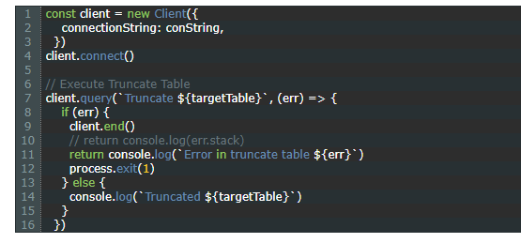

<pre class="theme:raygun lang:js decode:true " >

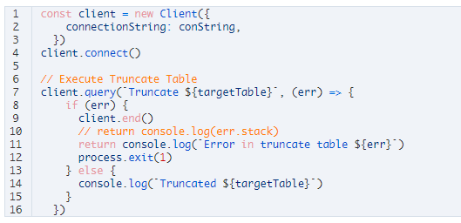

<pre class="theme:twilight font:verdana whitespace-before:1 whitespace-after:1 lang:js decode:true " >

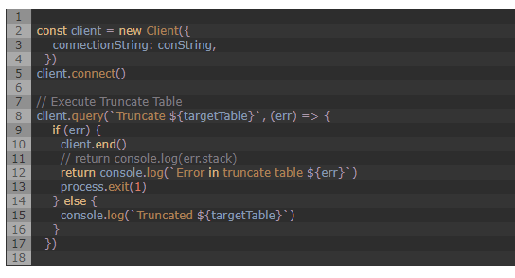

<pre class="theme:tomorrow-night lang:js decode:true " >

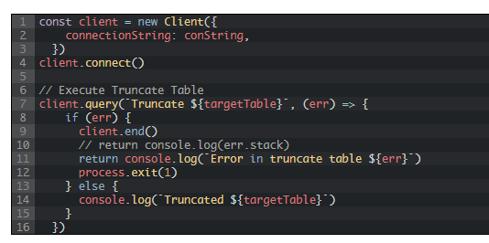

<pre class="theme:mirc-dark lang:default decode:true " >

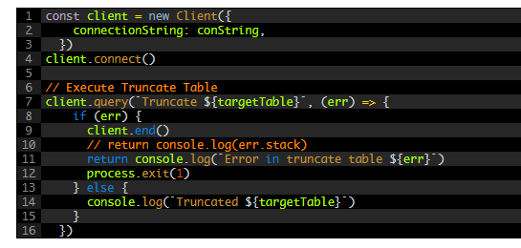

<pre class="theme:prism-like lang:default decode:true " >

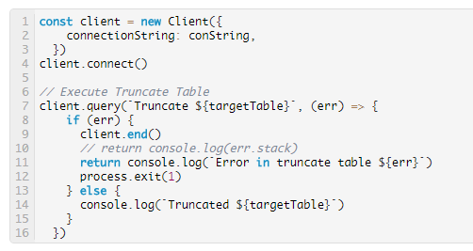

<pre class="theme:vs2012-black lang:js decode:true " >

